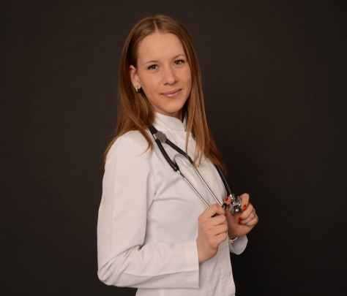
Solomiia Ruzhytska
+380935031713
s.siarkevych@gmail.com

Responsible, Ambitious, Goal oriented.

EDUCATION
10/2017 – to present – Academic leave of National Medical Academy of Postgraduate Education, Cardiology Department.
12/2016 to 09/2017 - Postgraduate student of National Medical Academy of Postgraduate Education, Cardiology Department.
12/2016 – Received a specialty as a cardiologіst.
06/2016 – Completed internship and received a specialty as a family doctor.
08/2014-06/2016 – Held internship in Kyiv City Clinical Hospital №3. Area of specialty: pulmonology, gastroenterology, therapeutic, cardiology, reception.
09/2008-06/2014 – Study at National Medical University named by O.O. Bogomolets. Received MD ( Medical Doctor).
09/2006-05/2008 - Study at National Medical Lyceum named by O.O. Bogomolets. After graduation received nurse certificate.
09/2000-05/2006 – High School Certificate from Gymnasium Kyiv Mohyla Collegium.

WORK EXPERIENCE
2012 to present – Part time working at the pharmaceutical company JSC “Farmak”. In pharmacovigilance department as a specialist of PSUR (Periodic Safety Update Reports), RMP (Risk Management Plan), SOP, literature searching. Than in clinical trials department as a specialist of medical and pharmaceutical management.

TRAINNG COURSES AND INTERNSHIPS
11/2017 – Participated in Jefferies Healthcare Conference 2017 (London).
11/2017 – Pharmaceutical exhibition CPhI Frankfurt.
06/2017 - Participated in the 27th European Meeting on Hypertension and Cardiovascular Protection (Milan). Received a certificate.

09/2016 – 11/2016 – Internship in Ministry of Health of Ukraine.
10/16 - Pharmaceutical exhibition CPhI Barcelona.
02/2016 - Nationwide training program for doctors. Express professional development course «Art of healiing». Received a certificate.
12/2015 –RSNA, Congress and radiological exhibition (Chicago).
10/2015 – Pharmaceutical exhibition CPhI Madrid.
06/2015 – 10/2015 – Internship in medical food supplement company (USA).
05/2015 - Ukrainian conference "Introduction into clinical practice of new standards for diagnosis and treatment of internal diseases". Received a certificate.
07/2014 – Internship in pharmaceutical consulting company (Germany): pharmacovigilance, clinical trials, medical writing, CTD dossier preparing.
06/2014 – Participant of pharmacovigilance workshop. Received a certificate.
10/2014 – Pharmaceutical exhibition CPhI Paris.
10/2013 – Applicant’s pharmacovigilance system: changes in the European legislation and legal support”. Received a certificate.
10/2013- Participant of the Third scientific and practical conference: “Safety and legal support for medical products: from development to medical use”, in memory of Oleksii P. Viktorov, doctor of medical sciences, professor. Received a certificate.
05/2013 – Participant of the workshop “Practical aspects of pharmacovigilance”. Received a certificate.
2010-2011 – Internsip at the Kyiv Burn Center.

SCIENTIFIC ACTIVITIES AT THE UNIVERSITY
04/2011 – Participated in the International Scientific Conference, devoted to the World health day 2011 “Antimicrobial resistance and its global spread”. Received a certificate.
05/2011 – Participant of scientific conference “Current issue of Clinical and Experimental Pharmacology”. Received a certificate.
11/2010 – Participant of 64th International Students’ and Young Scientists’ Conference “Actual Problems of Modern Medicine”. Received a certificate.

COMMITMENT
12/2016 –09/2017 – Member of the rehabilitation team of the Ministry of Health of Ukraine.
02/2016 - Member of Ukrainian Public Organization “Association of preventive and anti-aging medicine”
2014 - Until now - Member of the committee Friends of Ukrainian Catholic University.
2012 - Until now - Volunteered for mentally ill people.
2012-2013 - Worked as a volunteer in a psychiatric hospital in Kyiv.
2010 - Engaged in charity for children with impaired vision and hearing.
2008-2009- Active member of the student parliament at the university.
2005 - Engaged in charity for homeless children.
2002-2012 - Competition dance, Kyiv club “Kaleidoscope”.
1998-1999- Competition gymnastics, Gymnastics club Lviv .
1997-1999- pupil of music school (piano), Lviv music school.

COMPETENCION
Languages – Ukrainian (Primary Language), Russian (Fluent), English (Fluent), German (A2 Level), Polish (A2 Level).
IT – MS-Office, Excel.
HOBBIES
Reading, dancing, sport activities, traveling.

