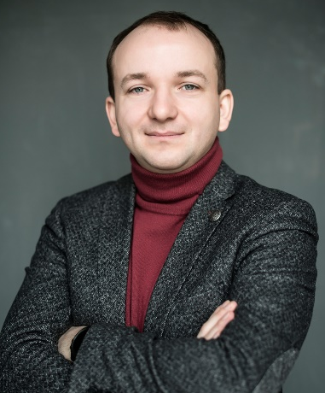
Roman Puchko

Born: August 30, 1988
Address: 4 Reheneratorna Str., apt. 7-282
02160 Kyiv, Ukraine
Mobile: 00 (38) 097 952 22 73
E-mail: roma.puchko@gmail.com

Personal summary
MSc in Economics and Management (profile Food & Agribusiness) with strong interpersonal, analytical and managerial skills. Possess with a comprehensive understanding of Agri & Food value chains. Believe in frugal innovations and circular economy principles as sustainable solutions to current business, environmental, and ethical challenges. Experienced in dairy and crop businesses, including smart farming technologies for efficiency maximization.

Currently most of my time is dedicated to ReThink, where we promote circular economy and mindful consumption in Ukraine.

Experience

November 2017 – still there  Kyiv, Ukraine  Co-Founder  at ReThink | - Promoting Circular Economy and mindful consumption in Ukraine  - Campaigning for minimization of unnecessary waste generation  - Innovations promotion through ecosystems development
April 2016 – October 2017  Kyiv, Ukraine  Coordinator in Ukraine  at Dutch Ukrainian Dairy Centre | - Coordination & organization of all trainings in all 3 clusters of the project – Lviv, Bila Tserkva/Uman, Sumy  - Communications management between all involved Dutch and Ukrainian partners (over 30 organizations)  - Support of institutional reform in Dairy industry by transferring Dutch expertise in I&R of animals, diseases monitoring and individual milk quality control
January 2014 – October 2017  Kyiv, Ukraine  Country Manager for Ukraine  at Difco International | - Business development of the company’s dairy (equipment, heifers, management consulting) and smart farming segments in Ukraine  - Development of guidelines for an efficient crops management on the basis of remote sensing via satellite  - Coordination of all company’s activities in Ukraine (including projects with IFC, EBRD etc.)  - Development of yearly business & finance plans
November 2013 – January 2014  Kyiv, Ukraine  Supply Chain Planning Manager  at LLC Milkiland N.V. | - Creation of supply chain planning procedure for the company  - Consolidation of weekly and monthly production plans, plans of semi-products and ready products stocks replenishment  - Coordination of weekly deliveries of goods between countries (Ukraine Russia; Poland Ukraine)  - Constant monitoring of stocks levels  - Working capital turnover management
March 2012 – October 2013  Kyiv, Ukraine  Raw Milk Procurement Manager  at SC Milkiland-Ukraine | - Management of information flows between 21 processing dairy plants (in Ukraine, Poland, Russia) and head office on every day basis regarding raw milk issues (quality, quantity, payments, logistics etc.)  - Audit of raw milk logistics cost and its optimization  - Milk on-site quality control and improvement  - Preparation of analytical reports on daily, weekly and monthly basis
July 2011 – March 2012  Kyiv, Ukraine  Marketing Executive  at SC Milkiland-Ukraine | - Deputy Dobryana brand manager in Cheese category  - Creation of Milkiland corporate posters, catalogues  - Re-make of the corporate web-site  - Re-launch of Dobryana logo  - Creation of Milkiland marketing strategy in cheese category for the year of 2012  - Preparation of analytical reports, overviews and suggestions for the top management
June 2008 –August 2008  Kyiv, Ukraine  Marketing Trainee  at Syngenta AG | - Preparation of markets outlooks of grains and oilseeds  - Research of trends and developments of markets  - Organization of agricultural shows on fields
March 2008 – September 2008  Kyiv, Ukraine  Trainee of Advisors Department  at Association “Ukrainian agribusiness club” | - Preparation and systematization of analytical data for specific research projects in rapeseed, turkey meat, and other markets  - Translations  - Management of website content,  - Author of the “Doing Agribusiness in Ukraine” brochure

Education
Period | Educational institution | Faculty/Specialization
2009-2011 | Wageningen University  (Wageningen, The Netherlands) | MSc in Management, Economics and Consumer Studies, Business Economics chair group, profile – Food and Agribusiness
2005-2011 | National University of Life and Environmental Sciences of Ukraine  (Kyiv, Ukraine) | Agricultural Management, MSc in Management of International Economic Activity

Foreign languages
Language | Level of spoken command | Level of written command
English | Fluent | Fluent
Russian | Fluent | Fluent
Polish | Basic | Basic
Dutch | Basic | Basic

Certificates
- Certificate on successful accomplishment of the “Networked Life” course by the University of Pennsylvania (2012);
- Certificate with distinction on successful accomplishment of the “Introduction to Operations Management” course by the University of Pennsylvania (2012);
- Global Management Challenge diploma for being a member of the best new team of the year 2012;
- Certificate on participation in ELLS Scientific Student Conference 2010, Copenhagen, Denmark;
- Driving license “B” category;
Skills of Software Operation
Office supplements | Experienced user of Microsoft Office software packages, all kinds of readers and browsers. User of SPSS 18, Xpress IVE and eViews.
Operational systems & environments | Microsoft Windows 98/XP/Vista/7/8/10, iOS 7,8.
Personal Traits:
Cheerful, optimistic, goal-seeking and responsible. Hobbies: singing, traveling, playing squash (#124 in Ukrainian national rating), unihockey, billiards and soccer. Value honesty, straightforwardness and adequateness in people.

